

**SECD 2613-15 SYSTEM ANALYSIS AND DESIGN**

**20232024 – SEMESTER 2**

**PHASE 3 - ANALYSIS AND DESIGN**

**Books Exchange platform**

**FACULTY OF MJIIT**

**GROUP 6**

|  |  |
| --- | --- |
| **NAME** | **MATRIC ID** |
| **Kahlan Sultan Mohammed** | **A23MJ4021** |
| **Liu Ruoyang** | **A23MJ4022** |
| **Buguoshun** | **A23MJ4019** |

**1.0 OVERVIEW OF THE PROJECT**

**2.0 PROBLEM STATEMENT**

**3.0 PROPOSED SOLUTIONS**

**4.0 CURRENT BUSINESS PROCESS/WORKFLOW**

**5.0 LOGICAL DF(AS-IS SYSTEM)**

**6.0 SYSTEM ANALYSIS AND SPECIFICATION**

**6.1 LOGICAL DFD TO-BE SYSTEM (CONTEXT DIAGRAM, DIAGRAM 0, CHILD)**

**6.2 PROCESS SPECIFICATION (BASED ON LOGICAL DFD TO-BE)**

**7.0 PHYSICAL SYSTEM DESIGN**

**7.1 PHYSICAL DFD TO-BE SYSTEM (DIAGRAM 0, CHILD, PARTITIONING, CRUD MATRIX, EVENT RESPONSE TABLE, STRUCTURE CHART, SYSTEM ARCHITECTURE)**

**8.0 SYSTEM WIREFRAME (INPUT DESIGN, OUTPUT DESIGN)**

**9.0 SUMMARY OF THE PROPOSED SYSTEM.**

1.0 OVERVIEW OF THE PROJECT

Our proposed "Book Exchange Platform" aims to alleviate the financial burden of textbooks for students amidst the rising costs of education. Students can buy, sell, or exchange textbooks and course materials with their peers, bypassing costly intermediaries. Key features include secure transactions, cost savings, and environmental sustainability. This platform not only meets students' needs but also fosters community and sustainability. With sponsorship support, our goal is to revolutionize access to course materials globally.

2.0 PROBLEM STATEMENT

We are planning to create an online book exchange platform to address the shortcomings of the current system. The main issues with the current platform are as follows:

1. **Difficulty in Finding Specific Books:** Users struggle to find specific books due to inadequate search functionality.
2. **Communication Barriers:** It is challenging for users to contact each other to arrange exchanges.
3. **Lack of Real-Time Updates:** The current system does not provide real-time updates on book availability, making it difficult to know if a book is available or already lent out.
4. **No Exchange Records:** The absence of exchange records makes it difficult to resolve disputes when returning books.

3.0 PROPOSED SOLUTIONS

To address the identified problems, we propose the following solutions:

1. **Enhanced Search Functionality:** Implement a robust search feature that allows users to filter books by keywords such as category, title, author, etc., making it easier to find specific books.
2. **Direct Communication Channels:** Provide a dedicated communication page for borrowers and lenders, enabling them to send messages and arrange exchanges directly.
3. **Real-Time Availability Updates:** Ensure real-time updates on the availability of books. When a book is borrowed, the system will automatically mark it as lent and close its public exchange link.
4. **Exchange Records:** Maintain exchange records containing the personal information of both parties on the platform. This record will be accessible through the dedicated communication page until both parties mark the exchange process as completed. In case of disputes, users can seek help through the platform. The records will be destroyed once the exchange process is finalized.

Project Objectives

1.Increase Accessibility: Provide students with a convenient platform to access affordable textbooks and course materials.

2.Alleviate Financial Pressure: Reduce students' financial burden by offering cost-effective options for textbooks.

3.Promote Community Engagement: Cultivate an inclusive environment for students to connect and collaborate.

These objectives reflect our vision of educational equity and student success, aiming to create a global learning environment that is open, inclusive, sustainable, and collaborative.

4.0 CURRENT BUSINESS PROCESS/WORKFLOW

Scenarios:

• Registration: User A registers on the book exchange platform by inputting his/her name, email address, and choosing favorite genres, including fiction and non-fiction.

• Listing a Book: User A chooses to recommend a book that was recently read; The Silent Patient by Alex Michaelides. They input information such as the title of the book, author, genre (psychological thriller), and its condition before labeling it as excellent.

• Search and Discovery: User A searches through other listings and discovers that User B has put up a copy of Tara Westover’s memoir “Educated”.

• Requesting an Exchange: User A requests User B to swap “The Silent Patient” with “Educated”. They use the platform’s internal messenger to organize everything and decide to swap books during one of the meetings in a coffee shop.

• Confirming the Exchange: As a result, User A and User B acknowledge the exchange through the platform. They both put a check on the transaction indicating that they are content with the exchange.

Workflow:

• Recipients register for the platform with basic information including name, email, and the creation of a profile. They may also state which specific types or genres of books they would like to get.

• Book Listing:

• Users share the books they are willing to swap. This includes inputting such information as title, author, genre, new/used and optionally additional description of the item.

• Search and Discovery:

• Other users read the available books on the platform. They can search using parameters such as title, author, type, or location to get a list of books that they want.

• Requesting an Exchange:

• If a user has come across a book they would like to borrow, they make a request for an exchange to the owner of the book. They may exchange messages over the platform regarding the exchange details including the meeting place or shipping.

Negotiation and Agreement:

• Since they are exchanging books, the terms and conditions of the exchange have to be worked out in some cases such as the condition of the books being exchanged, time of meeting to exchange the books or the delivery option. They enable these via platform communication tools before such particulars are gotten to a conclusive notation.

5.0 LOGICAL DF(AS-IS SYSTEM)

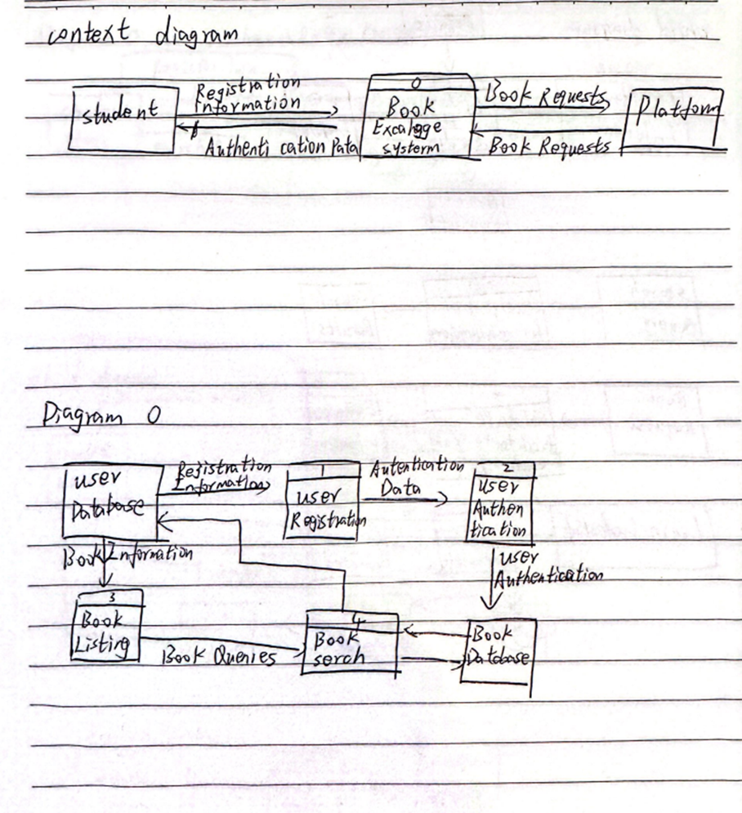

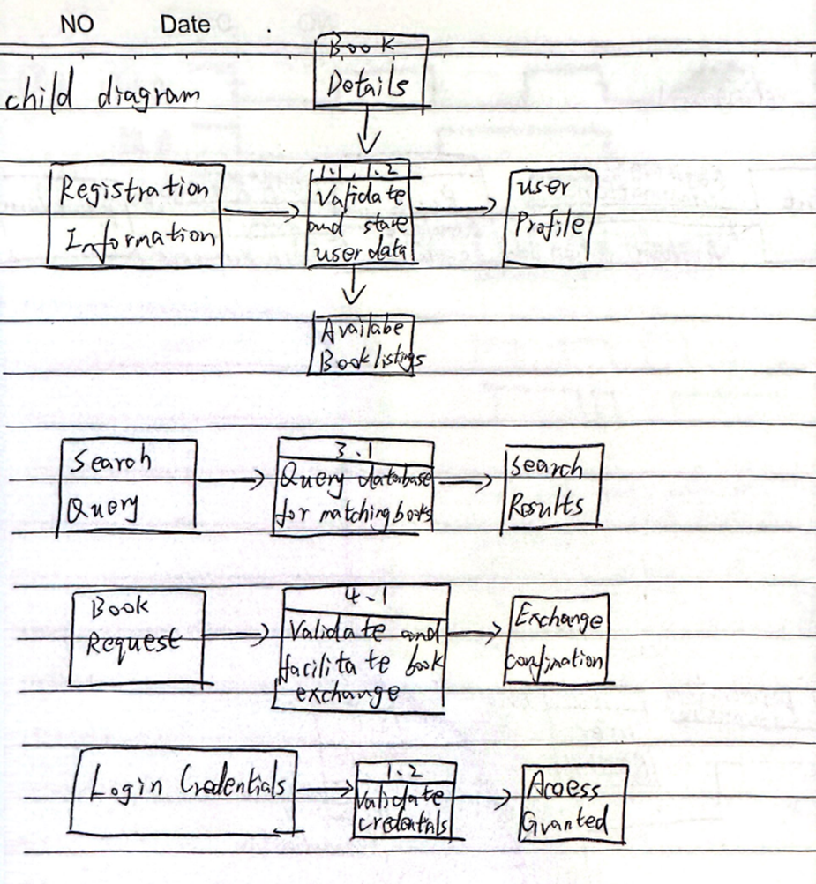

**6.0 SYSTEM ANALYSIS AND SPECIFICATION:**

**Introduction:**

* **Purpose:** Facilitate book exchanges among users and promote reading.
* **Scope:** Limited spatially and temporally; focuses on various types of book exchanges**.**

**Functional Requirements:**

* Secure user registration and identity verification.
* Users can post books for exchange with details like title, author, and condition.
* Search functionality by parameters such as title, author, and genre.
* Exchange management features for users to negotiate terms and confirm exchanges.
* Rating and feedback system post-exchange.
* Reputation system to assess user credibility.

**Non-Functional Requirements:**

* Performance: Fast search and response times; supports multiple concurrent users.
* Security: Secure online login and data storage; protects user privacy.
* Scalability: Able to accommodate increasing user base and book listings.

**System Design:**

* Architecture Overview: Client-server or cloud-based architecture.
* Database Design: Structure for user profiles, books, exchanges, and feedback.
* User Interface Design: Prototypes illustrating interface features.

**Testing and Validation:**

* Testing Strategy: Includes unit, integration, and user acceptance testing.
* Validation Criteria: Parameters to evaluate compliance with functional and non-functional requirements.

**Implementation Plan:**

* Development Phases: Backend coding, frontend design, and testing stages.
* Timeline and Milestones: Flowcharts for each phase with progress markers.

**Maintenance and Support:**

* Maintenance Strategy: Plans for ongoing maintenance, updates, and improvements.
* User Support: Help desk or knowledge base for user assistance.

**Legal and Compliance Considerations:**

* Data Protection: Compliance with GDPR, CCPA, and data protection principles.
* Terms of Service: Drafting user agreements outlining platform usage terms.

**Conclusion:**

* Summarizes key objectives and features of the platform.
* Emphasizes benefits to users and stakeholders.
* Advocates for a formal approach to ensure clear expectations and effective platform development.

**6.1 LOGICAL DFD TO-BE SYSTEM (CONTEXT DIAGRAM, DIAGRAM 0, CHILD)**

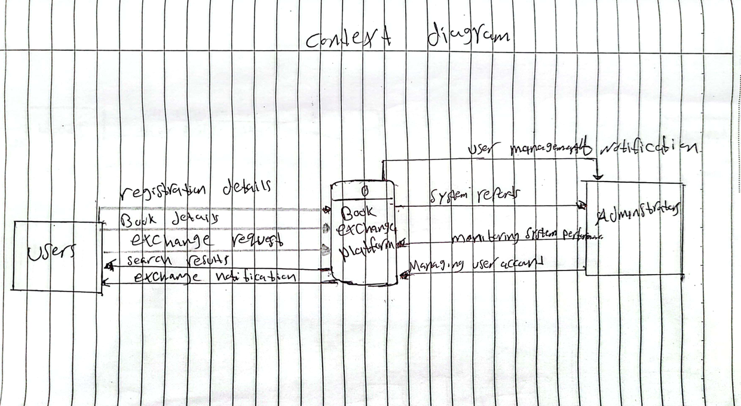

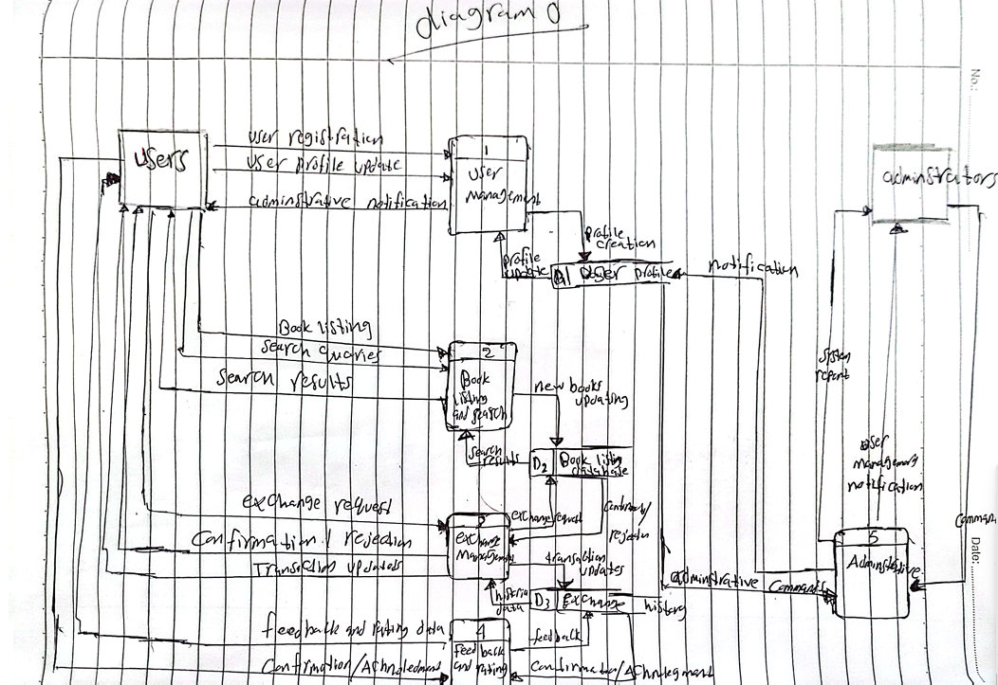

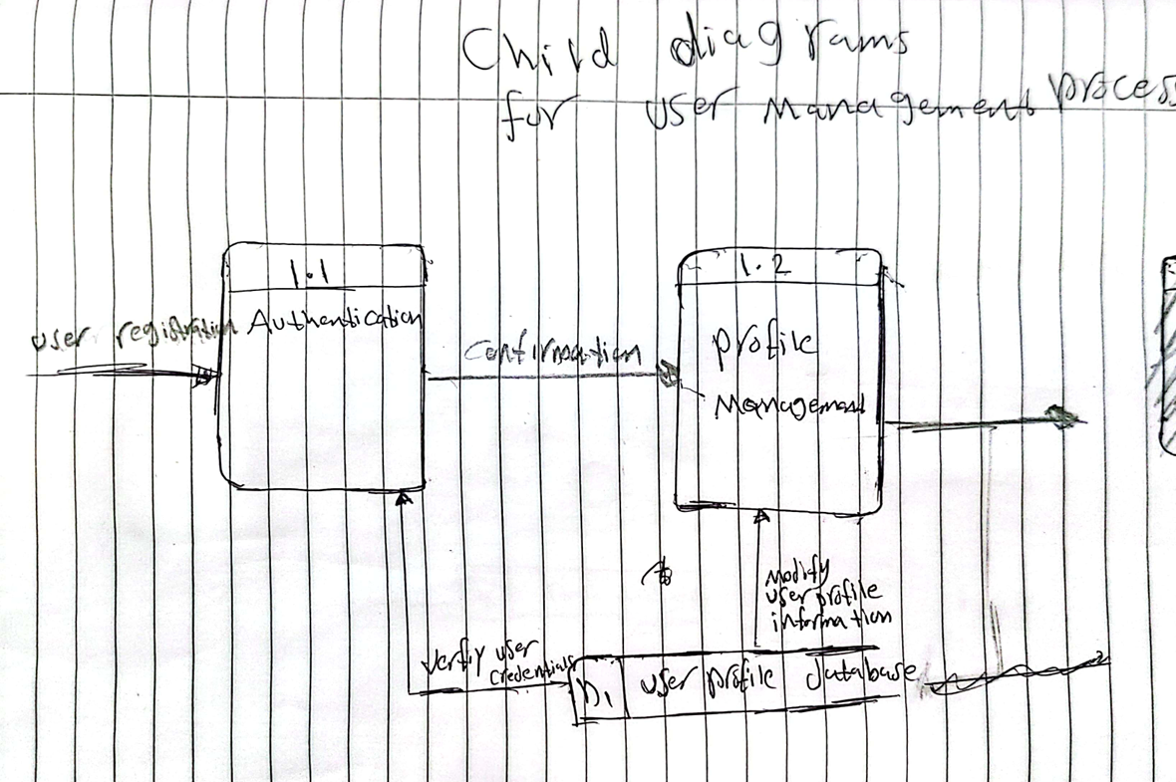

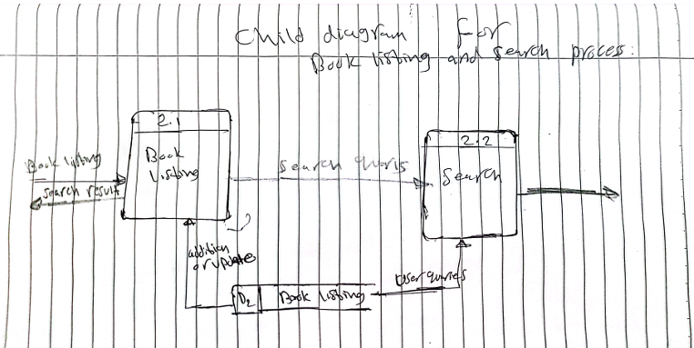

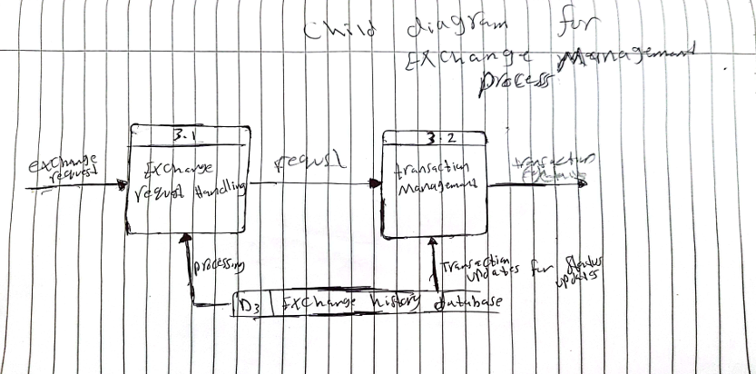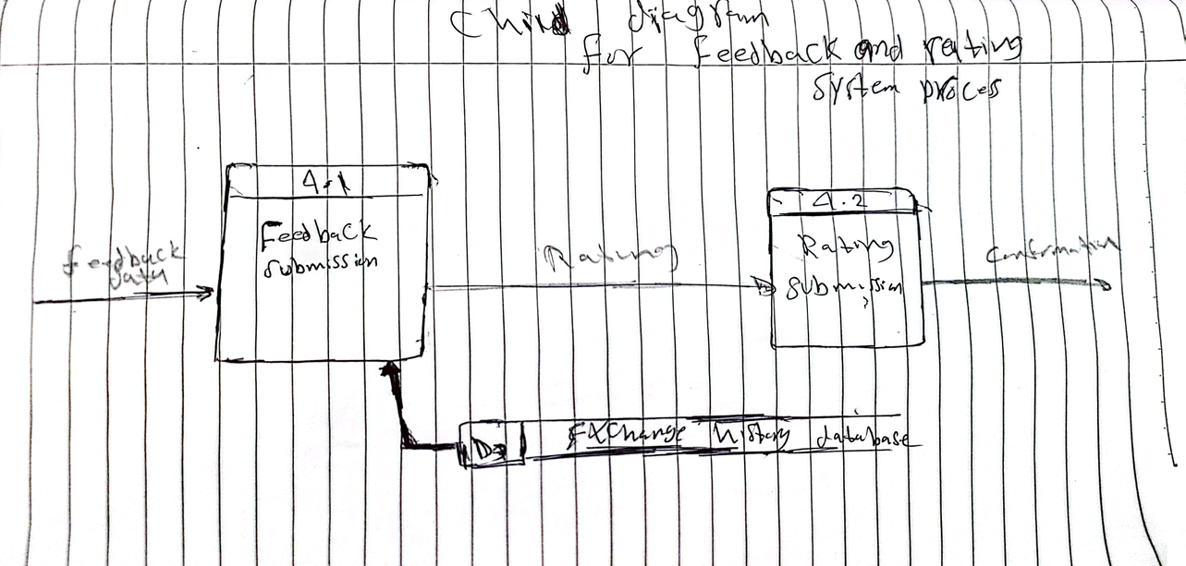

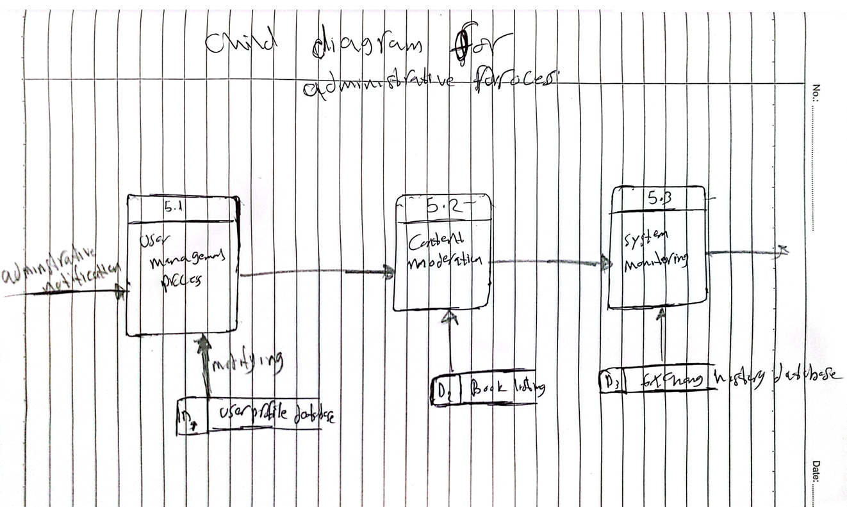

**6.2 PROCESS SPECIFICATION (BASED ON LOGICAL DFD TO-BE)**

**1. User Registration and Authentication:**

**o Purpose:** Allow users to create accounts and log in to the system.

**o Inputs:** Personal details for user registration (Name, Email id, Password), Login details (Email id and Password).

**o Outputs:** Acknowledgment, Status of the Authentication (Successful or Unsuccessful).

**o Data Stores:** The subject of this proposal – User Profiles Database – will be developed in a more detailed manner below.

**o Tasks:** Collect and save registration information, verify the user’s identity, confirm registration, and authorize users.

**o Control Flow Logic:** Ensure that the email entered is in the correct format and unique, check and compare log-in details with the stored information**.**

**2. Book Listing Management:**

**o Purpose:** Users should be able to post books they wish to swap.

**o Inputs:** Basic data about the book (title, author, its condition, etc. ).

**o Outputs:** Message for User.

**o Data Stores:** Book Listings Database.

**o Tasks:** Get book details, check and save into the database, ensure that books have been listed successfully.

**o Control Flow Logic:** For obvious checks – checking for mandatory fields, input errors or lack of information.

**3. Search and Browse Books:**

**o Purpose:** Allow the users to search for the books that are available as well as simply browse through the available books.

**o Inputs:** Research Keywords (Title, Author, Genre, etc. ).

**o Outputs:** List of Books Indexed (Depending on The Search).

**o Data Stores:** Book Listings Database.

**o Tasks:** Receive search queries, search the database and present matched book listings.

**o Control Flow Logic:** Provide search criteria processing (exact match, partial match), pagination and filtering**.**

**4. Exchange Request Management:**

**o Purpose:** Oversee the request of books by users for exchange between them.

**o Inputs:** Swap Offers (User A desires to swap Book X with the Book Y owned by User B).

**o Outputs:** Confirmation of Exchange Request Receipt, Modification of Exchange Status Information.

**o Data Stores:** Exchange History Database, User Profiles Database (containing information about the user).

**o Tasks:** Obtain and verify exchange requests, update status according to user feedback, manage transaction records.

**o Control Flow Logic:** User authentication, book availability, and timely updates on request status must be properly checked**.**

**Importance of Process Specifications:**

**• Clarity and Understanding:** Defines responsibilities, tasks, deliverables, and interfacing among various organizational member**s.**

**• Design and Development:** It helps system designers and developers in its implementation.

**Communication:** Facilitates effective communication among stakeholders**.**

**Conclusion:** Process specifications for the book exchange platform ensure structured definition and documentation of each process's functions and operations. By adhering to these specifications, the platform can operate efficiently, meet user needs, and align with business objectives related to book exchange activities.

**7.0 PHYSICAL SYSTEM DESIGN**

**7.1 PHYSICAL DFD TO-BE SYSTEM (DIAGRAM 0, CHILD, PARTITIONING, CRUD MATRIX, EVENT RESPONSE TABLE, STRUCTURE CHART, SYSTEM ARCHITECTURE)**

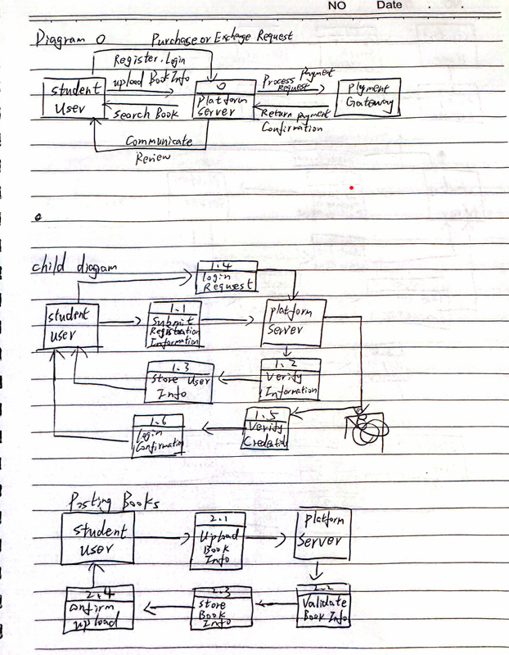

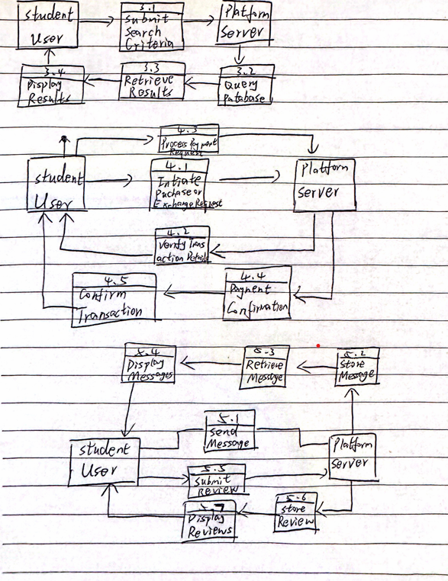

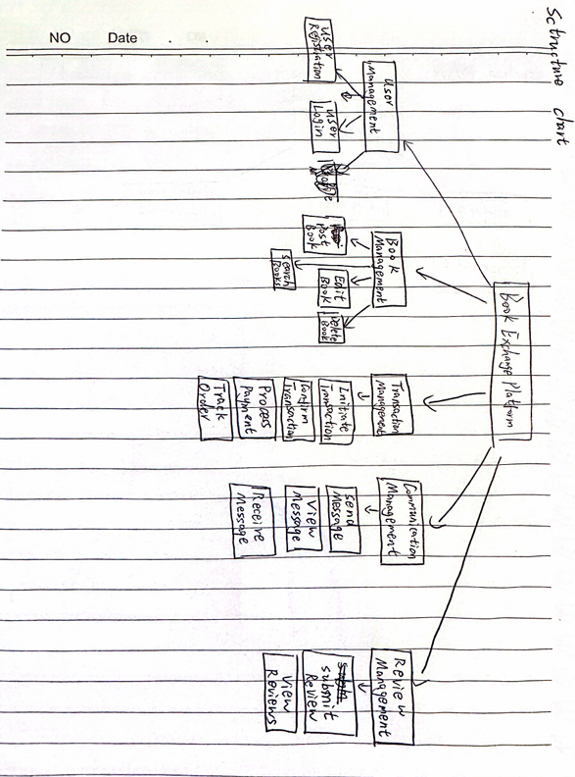

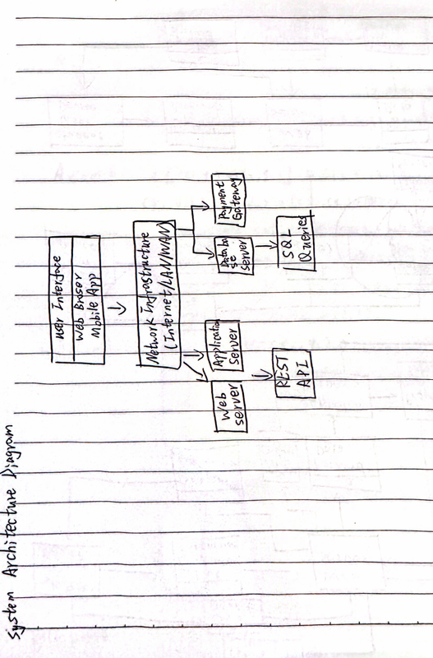

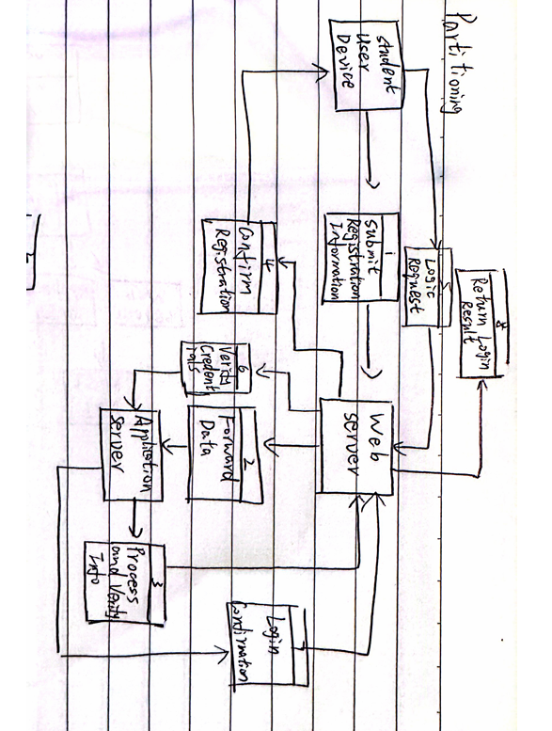

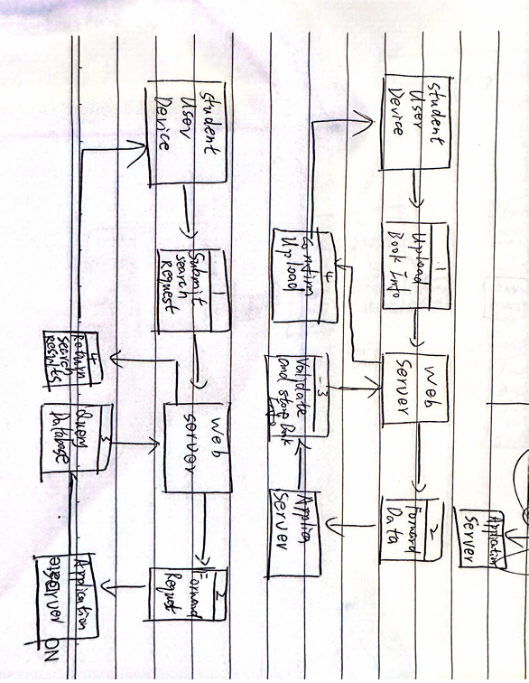

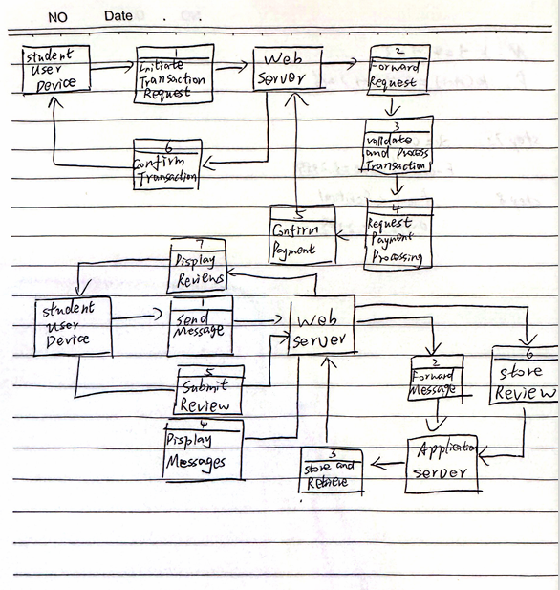

**CRUD Matrix**

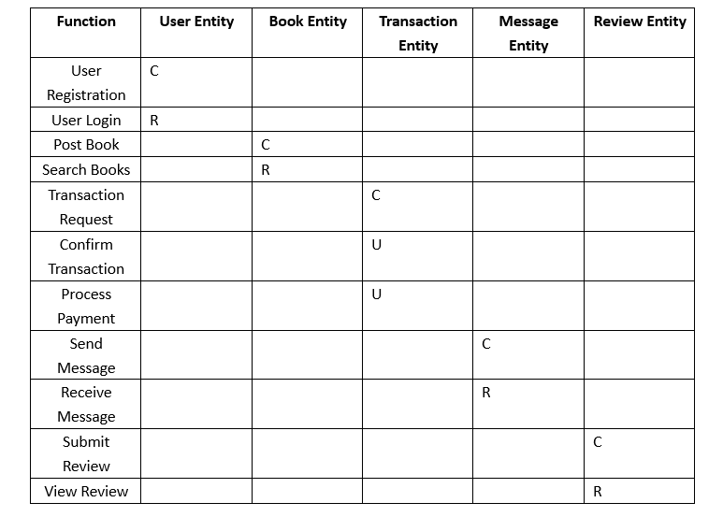

**Event Response Table**

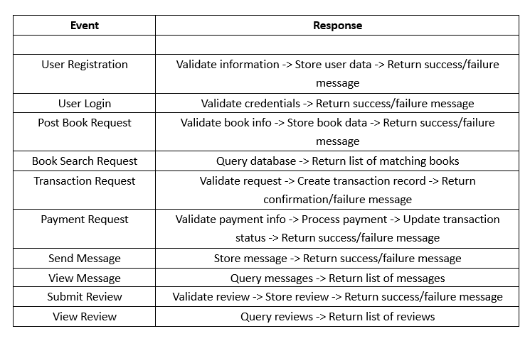

**8. System Wireframe**

**The Book Exchange Platform is designed to facilitate the exchange of books among users. It features a consistent LOGO on every page, and users must register or log in to access the system. This wireframe is designed using Figma. The main functionalities are divided into several key pages:**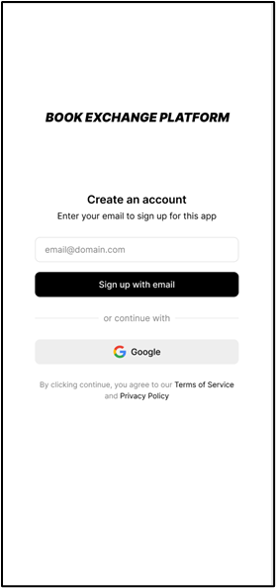

**Registration and Login Page**

* **Purpose: This is the entry point for users. They need to register or log in to proceed further into the system.**
* **Features:**
  + **Registration form for new users.**
  + **Login form for existing users.**

**Homepage**

* **Purpose: Displays the latest book exchange posts and allows users to create their own posts.**
* **Features:**
  + **Display of latest book exchange posts with book titles, descriptions, and images.**
  + **Option for users to create a new exchange post by entering the book title, description, and uploading an image of the book's condition.**
  + **"Chat" button for users to directly communicate with the owner of a post.**
  + **Redirection to a dedicated chat page for detailed discussions.**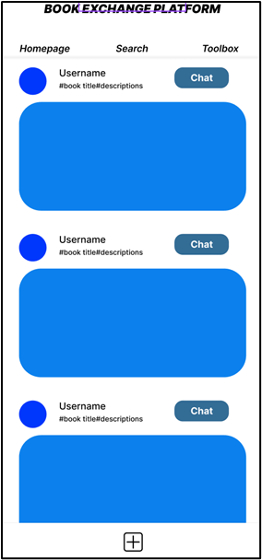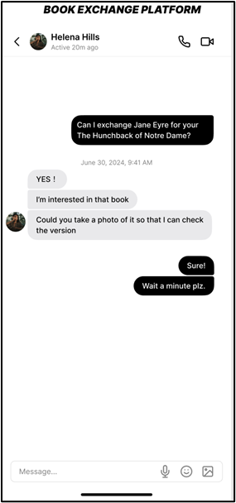

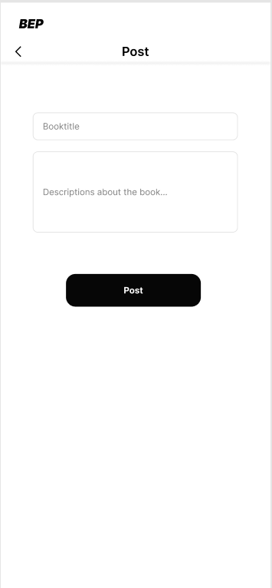

**Post**

* **A plus-shaped post button is set at the bottom of the page. Clicking it takes users to the post page where they can create their own posts.**

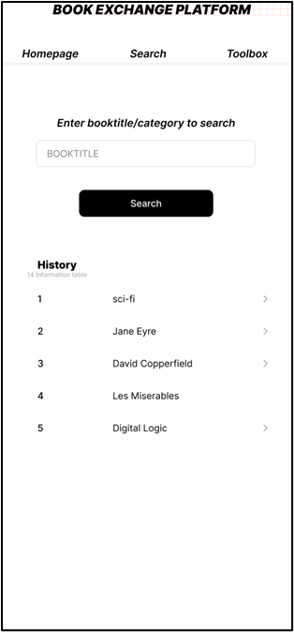

**Search Page**

* **Purpose: Enables users to search for specific books or filter posts based on book types.**
* **Features:**
  + **Search bar to input book titles/author/select book types for filtering exchange posts.**

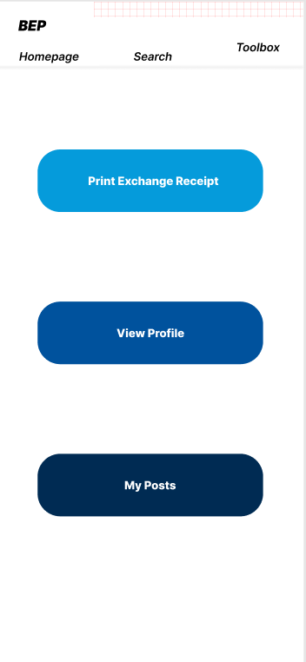

**Toolbox Page**

* **This page provides user with three entries including Print exchange receipt, View Profile and My posts**

**Sub-pages:**

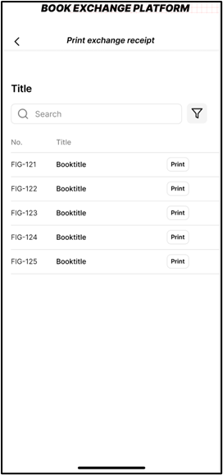

**Print Exchange Receipt**

* + **Purpose: Displays all book exchange records of the user.**
  + **Features:**
    - **List of all exchange records with details.**
    - **"Print" button to generate a PDF format receipt for each exchange, useful for platform accountability.**

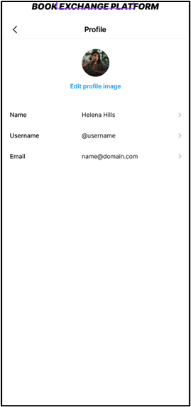

**View Profile**

* + **Purpose: Allows users to view and edit their personal information.**
  + **Features:**
    - **Display of user's personal information.**
    - **Option to edit personal details and change the profile picture.**

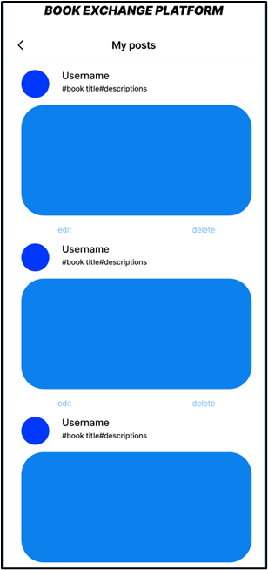

**My Posts**

* + **Purpose: Shows all exchange posts created by the user.**
  + **Features:**
    - **List of user's exchange posts.**
    - **Options to edit or delete individual posts.**

**The link to this whole design:** [**https://www.figma.com/design/Ni3HCufN7wTQwjdFDIu10W/Book-Exchange-Platform?node-id=0-1&t=4ljDzIn5VrXO24Z2-1**](https://www.figma.com/design/Ni3HCufN7wTQwjdFDIu10W/Book-Exchange-Platform?node-id=0-1&t=4ljDzIn5VrXO24Z2-1)

**9. Summary of the proposed system**

**Our new online book exchange platform addresses current system challenges by offering enhanced search functionality, real-time book availability updates, direct communication channels, and detailed exchange records. Users can easily register, list books, search, request exchanges. The platform ensures seamless communication and accountability, providing a streamlined and user-friendly book exchange experience.**

**For reading, some people choose e-books, while others seek the immersive experience of physical books. To help more people who need to exchange physical books, we decided to create this system. We hope this system can save people money on books, provide more reading options, and help people make like-minded friends. We will continuously update and improve this system to ensure its operation and better service.**

**For reading, some people choose e-books, while others seek the immersive experience of physical books. To help more people who need to exchange physical books, we decided to create this system. We hope this system can save people money on books, provide more reading options, and help people make like-minded friends. We will continuously update and improve this system to ensure its operation and better service.**